AI|ffinity and Chemspace Announce Strategic Partnership to Accelerate AI-Driven Drug Discovery
Collaboration integrates ligand epitope mapping platform with ultra-large compound libraries to streamline hit-to-lead progression
Prague/Brno, 2/2/2026. AI|ffinity s.r.o., developer of the deepHitExplorer NMR-AI platform for drug discovery, today announced a strategic partnership with Chemspace, a global provider of chemical compound libraries and discovery services. The collaboration creates an integrated workflow from virtual screening to biophysical validation, addressing a critical bottleneck in early-stage drug development.

Bridging Compound Identification and Validation
The partnership combines Freedom Space (142 billion molecules) and REAL Space (83 billion molecules) provided by Chemspace with AI|ffinity's deepHitExplorer platform, which uses explainable AI to predict complete ligand epitopes from NMR data. This enables researchers to not only identify hits but also understand which specific regions of a ligand interact with protein targets, a critical information for rational hit-to-lead optimization.
"Our deepHitExplorer platform uses explainable AI to predict complete ligand epitopes from NMR data, providing biophysical insights that traditional screening methods cannot deliver," said Thomas Evangelidis, CEO & CSO at AI|ffinity. "By integrating Chemspace's computational pre-screening and make-on-demand compound access, we're enabling researchers to progress from hit identification to epitope-mapped lead optimization with unprecedented efficiency, whether they use our software in-house or engage our services for the complete workflow."

Partnership Framework
Joint Proof-of-Concept Projects: Collaborative studies demonstrating the integrated workflow, with Chemspace performing computational pre-screening using proprietary cheminformatics tools and AI|ffinity conducting NMR-based epitope mapping and biophysical validation.
Integrated Data Pipeline: Chemspace will pre-screen its extensive chemical libraries to identify structurally diverse compounds sharing pharmacophore patterns with experimental hits. These high-quality, consistently prepared datasets will feed directly into deepHitExplorer for AI-driven epitope prediction, interaction mapping, and downstream optimization, supporting both customers using the software on-premises and those outsourcing to AI|ffinity's services.
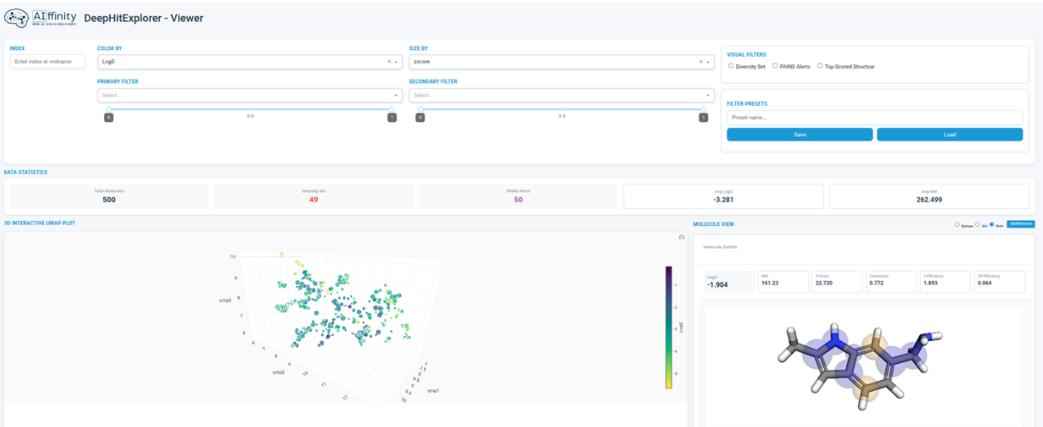
The platform uses explainable AI to predict complete ligand epitopes from NMR data. left: the screened library explored with deepHitExplorer - Viewer, an interactive 3D scatterplot, which captures compound diversity and supports clustering-based hit prioritization and selection. Right: Molecular viewer displaying the complete ligand epitope revealing predicted atoms involved in the interaction (epitopes, in yellow) together with the complete molecular contribution (blue).
"This collaboration with AI|ffinity focuses on integrating complementary tools to support drug discovery workflows," said Olga Tarkhanova, PhD, CEO at Chemspace. "AI-driven technologies are a game-changer in drug development, but the successful application of AI still depends on the quality of data. We at Chemspace are delighted to collaborate with AI|ffinity and provide access to our extensive compound collection. Together, we are building a more streamlined workflow for hit identification that connects the NMR-AI platform directly to our compound access and analog exploration capabilities."

Market Applications
Joint technical outputs, including white papers, case studies, and conference presentations, will demonstrate documented workflows for progression from virtual screening through epitope-mapped structural validation. AI|ffinity offers deepHitExplorer both as licensed software for organizations with existing NMR infrastructure and biophysical data, and as a full-service solution for clients outsourcing the complete hit discovery and optimization pipeline.

About AI|ffinity
AI|ffinity develops deepHitExplorer®, an NMR-AI platform featuring proprietary ligand epitope prediction technology that accelerates early-stage drug discovery. The platform combines artificial intelligence with nuclear magnetic resonance spectroscopy to provide epitope-level insights into protein-ligand interactions, particularly for challenging targets including intrinsically disordered proteins. AIffinity is also the developer of 4D-GraFID®, a machine learning software for automatic chemical shift assignment and structure determination from 3D, 4D NMR spectra that enhances analysis of intrinsically disordered proteins and extends NMR capabilities to proteins above 20 kDa.
Web: https://www.aiffinity.com/
About Chemspace
Chemspace is a global provider of drug discovery services and chemical compounds. Their platform integrates advanced computational chemistry, bioinformatics, and machine learning-driven services to accelerate hit discovery and optimization. By exploring ultra-large chemical spaces like Freedom Space (142 billion molecules) and Enamine REAL Space (83 billion molecules), Chemspace identifies high-quality hit molecules for further biological validation. Chemspace’s online platform enables searches across more than 18 billion small molecules and over 880,000 biologics, including antibodies, peptides, and proteins.
Web: https://chem-space.com/

Media Contact
AI|ffinity
Thomas Evangelidis, Ph.D.CEO & CSO
Email: tevang@aiffinity.com
https://aiffinity.com/
Chemspace
Olga Tarkhanova, Ph.D. CEO
Email: o.tarkhanova@chem-space.com
https://chem-space.com

